The Mixed Nuts
Christmas CD Set Last revised on 2015.01.01

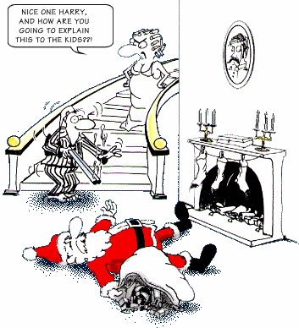
ChristmasCD-01-Happy Holiday(KVF).2014.12.12.pdf
ChristmasCD-02-I'll Be Home For Christmas(KVF).2014.01.06.pdf
ChristmasCD-03-Let It Snow(KVF).2014.12.12.pdf
ChristmasCD-04-Have Yourself A Merry Little Christmas(KVF).2014.12.06.pdf
ChristmasCD-05-Christmas Island(KVF).2014.01.06.pdf
ChristmasCD-06-Nuttin' For Christmas(KV).2014.01.06.pdf
ChristmasCD-07-Christmas Song (KVF).2014.12.08.pdf
ChristmasCD-08-Jolly Old St. Nick(KVF).2014.12.14.pdf
ChristmasCD-09-Jingle Bell Rock(KVF).2014.12.16.pdf
ChristmasCD-10-Christmas Waltz, The(KVF).2014.01.06.pdf
ChristmasCD-11-Hang Up Your Stocking(KVD).2014.12.14.pdf
ChristmasCD-12-Home For The Holidays(KVF).2014.11.18.pdf
ChristmasCD-13-It's Beginning To Look A Lot Like Christmas(KVF).2014.12.03.pdf
ChristmasCD-14-Jingle Bells(KVD).2014.12.16.pdf
ChristmasCD-15-Winter Wonderland(KVF).2014.12.14.pdf
ChristmasCD-16-Santa, Baby(KV).2014.12.21.pdf
ChristmasCD-17-Rockin' Around The Christmas Tree(KVF).2014.12.16.pdf
ChristmasCD-18-Merry Christmas, Darling(KVF).2014.01.06.pdf
ChristmasCD-19-Rudolph, The Red-Nosed Reindeer(KVF).2014.01.06.pdf


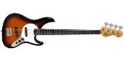

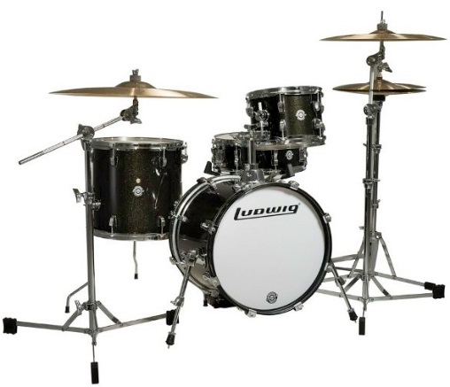

ChristmasCD-20-We Wish You A Merry Christmas(KVD).2015.01.01.pdf

